`

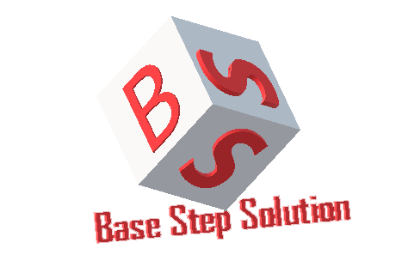

Meeting Minutes

Van Lang Admissions

# Revision Table

|  |  |  |  |
| --- | --- | --- | --- |
| Author | Date | Reason for changes | Version |
| Khoi Nguyen | 08/11/2017 | Initial Document | 1.0 |

Table of Contents

Revision Table 1

I. Purpose 3

II. Participant in meeting 3

III. Content of meeting 3

IV. To do task 4

|  |  |  |  |  |  |
| --- | --- | --- | --- | --- | --- |
| **Writer:** | Khởi Nguyễn | **Location:** | Room 706A | | |
| **Date:** | 08/11/2016 | **Start:** | 10h45 | **Finish:** | 12h15 |

# Purpose

* Review Process
* Discuss about incremental process

# participant in meeting

Mentor Lê Sĩ Phú

Team Capston:

* Nguyễn Thái Hiền
* Nguyễn Hoàng Anh Tài
* Đoàn Anh Minh
* Trần Xuân Hải
* Nguyễn Xuân Thái Hiền
* Nguyễn Anh Khởi

# Content of meeting

- Review incremental process

+ Advantage :

Flexible than water fall model , wrong when compare with agile model

Scrum’s stability isn’t high

+ Disadvantage : may be acceptable.

+ Compare with Water fall model & Srum model

1. Not all and frequently : wrong.
2. Project cost : wrong
3. Guarantee of success : Where to evaluation based on ?
4. Required expertise : no measure (most companies based on years of experience )
5. Overlapping phase : don’t understand

14. Risk involment : why low ?

+ Discuss about scope of project.

+ Discuss about process decision.

# To do task

* Update Master Plan
* Update Processes

---- *** ----